Fix Corrupt Numbering

This document shows how to fix number in Word when the numbering becomes black rectangles. Here is an example.

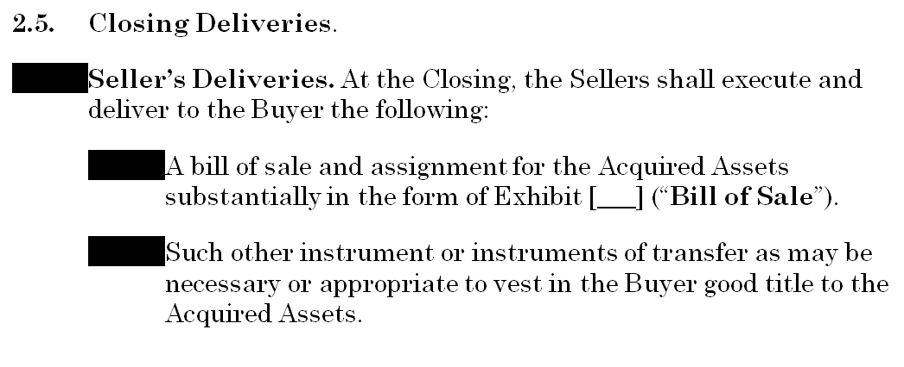

After you’ve opened the document, type CTRL+F11 to open Microsoft Visual Basic for Applications.

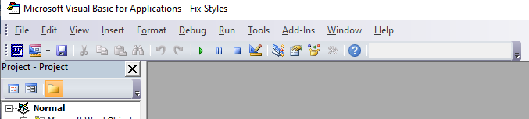

Go to Insert then Module.

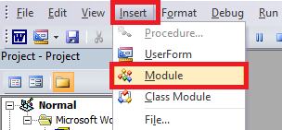

Copy and paste the following subroutine into the module window.

Sub RemoveBlackBox()

' RemoveBlackBox Macro

For Each templ In ActiveDocument.ListTemplates

For Each lev In templ.ListLevels

lev.Font.Reset

Next lev

Next templ

End Sub

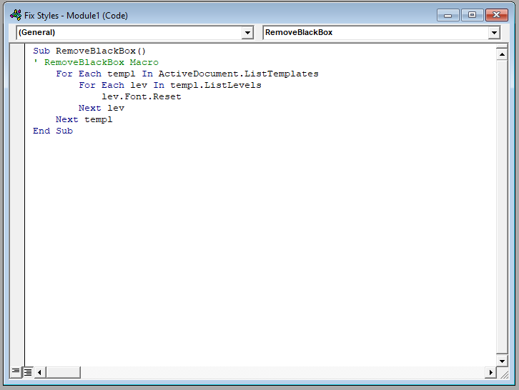

Click the Run Sub button.



The numbering should no longer be black rectangles.

Your existing document is likely a macro-free document. If that’s the case, Word will ask if you want to continue to save the file as a macro-free document. You should save as a macro-free document. The subroutine we used will not be saved in the document.

